Joshua Evans

2024-04-04

CS 276

# Practice Overview Activity/Attendance

## Screenshot

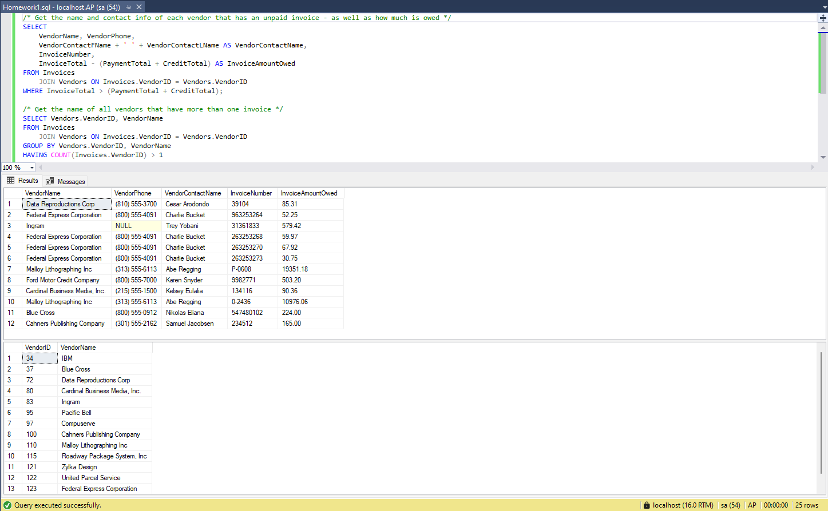

## Queries

/* Get the name and contact info of each vendor that has an unpaid invoice - as well as how much is owed */

SELECT

VendorName, VendorPhone,

VendorContactFName + ' ' + VendorContactLName AS VendorContactName,

InvoiceNumber,

InvoiceTotal - (PaymentTotal + CreditTotal) AS InvoiceAmountOwed

FROM Invoices

JOIN Vendors ON Invoices.VendorID = Vendors.VendorID

WHERE InvoiceTotal > (PaymentTotal + CreditTotal);

/* Get the name of all vendors that have more than one invoice */

SELECT Vendors.VendorID, VendorName

FROM Invoices

JOIN Vendors ON Invoices.VendorID = Vendors.VendorID

GROUP BY Vendors.VendorID, VendorName

HAVING COUNT(Invoices.VendorID) > 1